**WEKA**

Auto-WEKA aims to aid non-expert users of machine learning techniques. The simplest approach for selecting a classifier that is widely adopted amongst non-experts is to use a classifier merely based on its popularity or intuitive appeal, without any empirical consideration of alternatives.

Increasingly, users of machine learning tools are non-experts who require off-the-shelf solutions. The machine learning community has much aided such users by making available a wide variety of sophisticated learning algorithms and feature selection methods through open source packages such as WEKA

Each of these packages asks a user to make two kinds of choices: selecting a learning algorithm and customizing it by setting its hyperparameters

It can be challenging to make the right choice when faced with these degrees of freedom, leaving many users to select algorithms based on reputation or intuitive appeal, and/or to leave hyperparameters set to default values. Of course, this approach can yield performance far worse than that of the best method and hyperparameter settings.

These hyperparameters are typically optimized in an “outer loop” that evaluates theperformance of each hyperparameter configuration using cross-validation.

We also show that — based on this problem formulation — recent Bayesian optimization methods can obtain high quality results in reasonable time and with minimal human effort. After

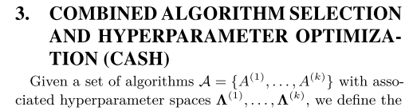

To demonstrate the feasibility of an automatic approach to solving the CASH problem, we built a tool, Auto-WEKA, that solves this problem for all classification algorithms and feature selectors/evaluators implemented in the WEKA pack- age

All datasets had a RAM limit of 3GB for classification; if training a classifier ever exceeded this memory limit, the classifier job was terminated, returning a misclassification rate of 100%. An additional 1GB of RAM was allocated for the SMBO method. While these limits are somewhat arbitrary, we believe them to be reasonably close to the resource limitations faced by any user of machine learning algorithms.

The results just shown demonstrate that Auto-WEKA is effective at optimizing its given objective function; however, this is not sufficient to allow us to conclude that it fits models that generalize well.